# Exercise - Promote to the Dev stage

The team has a plan and is ready to begin implementing their release pipeline. You've set up your Azure DevOps project, and your Azure App Service instances are ready to receive build artifacts.

At this point, remember that the team's pipeline has only two stages. The first stage produces the build artifact. The second stage deploys the Space Game web application to App Service. Here you follow along with Andy and Mara as they modify the pipeline. They'll deploy to the App Service environment that corresponds to the Dev stage.

The Dev stage resembles the deployment stage that you made in the **Create a release pipeline in Azure Pipelines  module**. There, you used a CI trigger to start the build process. Here you do the same.

## Fetch the branch from GitHub

Here you fetch the release branch from GitHub. You also check out, or switch to, the branch.

This branch serves as your release branch. It contains the Space Game project that you used in previous modules. It also contains an Azure Pipelines configuration to start with.

To fetch and switch to the branch:

1. In Visual Studio Code, open the integrated terminal.
2. Run the following git commands to fetch a branch named release from the Microsoft repository and to switch to that branch.

**Bash**

**git fetch upstream release**

**git checkout -b release upstream/release**

The format of these commands enables you to get starter code from the Microsoft GitHub repository, known as upstream. Shortly, you'll push this branch up to your GitHub repository, known as origin.

1. As an optional step, open azure-pipelines.yml from Visual Studio Code. Familiarize yourself with the initial configuration.

The configuration resembles the basic one that you created in the Create a release pipeline with Azure Pipelines  module. It builds only the application's release configuration. For learning purposes, this configuration doesn't run the quality or security checks that you set up in previous modules.

**Note**

A more robust configuration might specify the branches that participate in the build process. For example, to help verify code quality, you might run unit tests each time you push up a change on any branch. You might also deploy the application to an environment that performs more exhaustive testing. But you do this deployment only when you have a pull request, when you have a release candidate, or when you merge code to master.

## Promote changes to the Dev stage

Here you modify your pipeline configuration to promote the build to the Dev stage.

1. In Visual Studio Code, modify azure-pipelines.yml:

**yml**

trigger:

- '*'

variables:

buildConfiguration: 'Release'

releaseBranchName: 'release'

stages:

- stage: 'Build'

displayName: 'Build the web application'

jobs:

- job: 'Build'

displayName: 'Build job'

pool:

vmImage: 'ubuntu-18.04'

demands:

- npm

variables:

wwwrootDir: 'Tailspin.SpaceGame.Web/wwwroot'

dotnetSdkVersion: '3.1.300'

steps:

- task: UseDotNet@2

displayName: 'Use .NET Core SDK $(dotnetSdkVersion)'

inputs:

version: '$(dotnetSdkVersion)'

- task: Npm@1

displayName: 'Run npm install'

inputs:

verbose: false

- script: './node_modules/.bin/node-sass $(wwwrootDir) --output $(wwwrootDir)'

displayName: 'Compile Sass assets'

- task: gulp@1

displayName: 'Run gulp tasks'

- script: 'echo "$(Build.DefinitionName), $(Build.BuildId), $(Build.BuildNumber)" > buildinfo.txt'

displayName: 'Write build info'

workingDirectory: $(wwwrootDir)

- task: DotNetCoreCLI@2

displayName: 'Restore project dependencies'

inputs:

command: 'restore'

projects: '**/*.csproj'

- task: DotNetCoreCLI@2

displayName: 'Build the project - $(buildConfiguration)'

inputs:

command: 'build'

arguments: '--no-restore --configuration $(buildConfiguration)'

projects: '**/*.csproj'

- task: DotNetCoreCLI@2

displayName: 'Publish the project - $(buildConfiguration)'

inputs:

command: 'publish'

projects: '**/*.csproj'

publishWebProjects: false

arguments: '--no-build --configuration $(buildConfiguration) --output $(Build.ArtifactStagingDirectory)/$(buildConfiguration)'

zipAfterPublish: true

- publish: '$(Build.ArtifactStagingDirectory)'

artifact: drop

- stage: 'Dev'

displayName: 'Deploy to the dev environment'

dependsOn: Build

condition: |

and

(

succeeded(),

eq(variables['Build.SourceBranchName'], variables['releaseBranchName'])

)

jobs:

- deployment: Deploy

pool:

vmImage: 'ubuntu-18.04'

environment: dev

variables:

- group: Release

strategy:

runOnce:

deploy:

steps:

- download: current

artifact: drop

- task: AzureWebApp@1

displayName: 'Azure App Service Deploy: website'

inputs:

azureSubscription: 'Resource Manager - Tailspin - Space Game'

appName: '$(WebAppNameDev)'

package: '$(Pipeline.Workspace)/drop/$(buildConfiguration)/*.zip'

This configuration resembles the one that you built in the previous module. There, you and the team built a proof of concept (POC) for continuous deployment. But note these differences, which are highlighted in the preceding code example:

* + This configuration defines variables at the top of the file. The variables are used throughout the pipeline. They define which configuration to build (Release). They also define the name of your release branch (release).
  + The **Deploy** stage from the POC is now named **Dev**.
  + The **Dev** stage uses a condition that directs the system to run the stage only when the previous stage succeeds and the current branch is release. This setup ensures that release features are deployed only to the Dev environment.
  + The deployment step uses the WebAppNameDev variable to deploy to the App Service instance that's associated with the Dev environment.

**Note**

In practice, you might deploy from some other branch, such as master. You can include logic that allows changes to be promoted to the Dev stage from multiple branches, such as release and master.

1. From the integrated terminal, add azure-pipelines.yml to the index. Commit the change and push it up to GitHub.

**Tip**

Save azure-pipelines.yml before you run these Git commands.

**Bash**

**git add azure-pipelines.yml**

**git commit -m "Deploy to the Dev stage"**

**git push origin release**

1. In Azure Pipelines, go to the build. Trace the build as it runs.
2. After the build finishes, select the back button to return to the summary page.

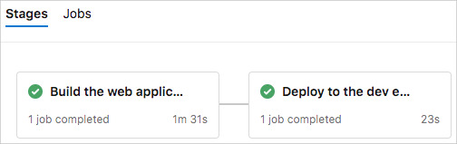

You see that the deployment finished successfully.

1. From a web browser, navigate to the URL that's associated with the App Service instance for your Dev environment.

If you still have the browser tab open, refresh the page. If you don't remember the URL, find it in the Azure portal, on the App Service details page.

You see that the Space Game website is deployed to App Service and is running.

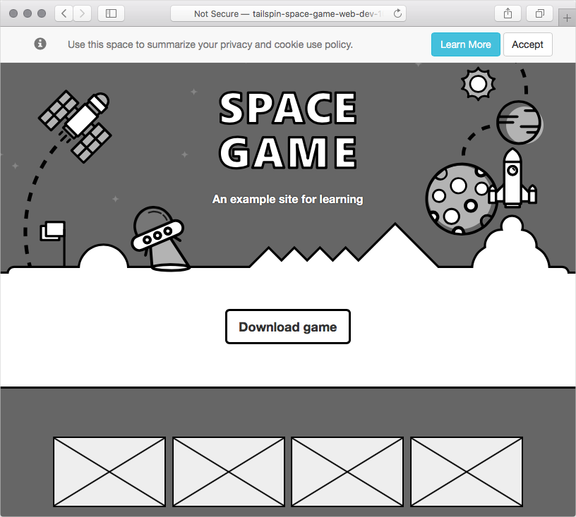

1. As an optional step, in Azure Pipelines, select **Environments**. Then select the **dev** environment.

Azure Pipelines records your deployment history. In the history, you can trace the environment's changes back to code commits and work items.

